CURRICULUMN VITAE

DINH QUANG THUAN |  |  |  | 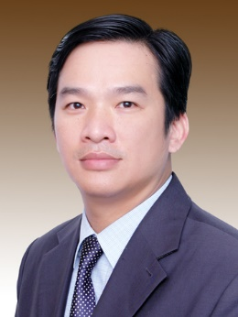
 | Partner, Global Vietnam Lawyers
 | Global Vietnam Lawyers HCMC, 8th Floor, Centec Tower, 72-74 Nguyen Thi Minh Khai Street, District 3, Ho Chi Minh City
 | 0918 116 704
 | thuan.dinh@gvlawyers.com.vn
 | Employment/ Labor, Tax, Dispute Resolution, Insurance
 | English, Vietnamese
Education
Qualifications |  | Bachelor Degree of Law
Major(s) |  | Law
University(s) |  | Ha Noi Law University, Vietnam
Work history
1990 - 2003 |  | People’s Court of Ho Chi Minh City
2003 - 2008 |  | Key litigator, Vilaf – Hong Duc
2008 - 2019 |  | Partner, Phuoc & Partners
At present |  | Partner, Global Vietnam Lawyers
Membership and Activities
 |  | CIArb Diploma (Singapore)
 |  | VMC Mediator/ CEDR Accredited Mediator
 |  | CEDR Mediator Skills Training (Ho Chi Minh City)
Cases handled
 |  | Legal actions against a tax agency to decline a tax obligation equal to 7 million USD
 |  | Defending a world famous soft drink manufacturer in labour disputes against employees,
 |  | Handling dispute among members of a 5-star hotel joint venture,
 |  | Representing a foreign contractor in resolving dispute over the construction of a high-class housing project,
 |  | Handling maritime cases which include applying for arrest and release of sea-going vessels,
 |  | Representing a foreign well-known insurer in subrogation cases, representing foreign top cotton and feeds traders in enforcing foreign arbitral awards in Vietnam
 |  | Handling large number of debt collection cases for both local and overseas clients including HSBC Vietnam, Dekalb Vietnam, Shell Vietnam, Basf Vietnam, AG Processing Inc., Olam International, VNG ….
 |  | Defending a world famous soft drink manufacturer in labour disputes against employees,
Articles
 |  | The Article of “Troubles Inherent in Processing Contracts” on Saigon Economic Times Magazine.
 |  | The Article of “Ordinance on Arrest of Ship – A Long Awaited Act” on Saigon Economic Times Magazine.
 |  | Co-author of the book Asia Arbitration Guide 3rd Edition 2013
 |  | NDA dispute, how to handle it

